COP 4331-002  
S Hassan Shaikh, Austin Vesquez, Jorge Martinez, Divyesh Mangapuram  
10/26/2023  
Option A: Shopping Cart Design Specifications

Shopping Cart Application

Functional specifications   
The app allows a user to register or log in either as a customer or a seller. Sellers can sell new products and review or update existing products. Customers can review products, add them to their cart, review or update their shopping carts, and check out.

The platform the Shopping Cart Application will be developed on is Swing UI (User Interface).

# Glossary

Account: An ideally unique identifier for an individual user, containing their information.

Class: A representation of an object in programming.

CRC: Class, responsibilities, and collaborators; defines the responsibilities of a class and what classes it works with to achieve those responsibilities.

Credentials: Username, password, and email address; The proof an individual owns an account.

Customer: An individual who serves the purpose of purchasing products.

Inventory: The stock of products a seller has for offer.

Item: An unspecified material object.

Login: The act of entering an application with an individual account.

Password: A private key word used to gain access to an account associated with a username.

Product: An item put up for sale.

Registration: The act of creating an account for an application.

Seller: An individual who serves the purpose of offering and selling products.

Sequence: A series of events resulting in an action.

Shopping Cart: A container for all the items that a customer is planning to purchase.

Stakeholder: A person or group with involvement in or control over the design decisions of the software such as developers and sponsors.

State: The current environment and situation.

Specification: The required functionality posed by the stakeholders.

UI: User Interface; the front for the software that the user interacts with.

UML: Unified Modelling Language; a method of representing classes, sequences, states, etc. Via graphs when designing software.

Use Case: A scenario about a user’s interaction with the software and the step-by-step protocols to consider.

User: The individual who interacts with the software.

Username: A public identifier for a user’s account.

UX: User experience; the experience of the user’s interaction with the software, this includes UI.

# Use Cases

**Use Case: User Logs In**

Actor:

User

Preconditions:

The user has already registered an account on the shopping cart app.

The app is accessible and running.

Main Flow:

1. The user opens the shopping cart app.
2. The app displays the login screen, which includes fields for the user to enter their login credentials:  
   * Username  
   * Password
3. The user enters their registered username and password.
4. The app validates the entered credentials:  
   * The app checks if the username exists in the database.  
   * The app verifies that the entered password matches the stored password for the corresponding user account.
5. User logs in  
   * The app logs the user in.  
   * The user is redirected to the app's home screen after a successful login.

Alternative Flow:

5a. User inputs incorrect credentials  
 * The app displays an error message ("Incorrect credentials.").  
 * The user is prompted to re-enter their login credentials.

**Use Case: User Changes/Updates their Login Credentials and Balance**

Actor:

User

Preconditions:

The user has already logged in to their account.

The app is accessible and running.

Main Flow:

1. The user navigates to the "User Settings" page.
2. The user can update their name, username, password, and add to their balance.
3. The app validates the information.
4. If the information is valid, the app updates the user information and returns to user settings screen.

Alternative Flow:

4a. If the user did not enter a valid fund amount, all other changes are saved and displays an error message pertaining to an invalid fund field.

**Use Case: Customer Adds Items to Shopping Cart**

Actor:

User

Preconditions:

Items have been added to the database and marked for sale by a seller.

User has shopping cart app open and is logged in.

User has the shopping menu open.

User has added enough balance to afford the items for purchase

Main Flow:

1. User selects an available item.
2. The user can choose how many of the item they want.
3. Item is added to the user's shopping cart.
4. User enters into the shopping cart to checkout.
5. User chooses to complete transaction, a receipt is displayed and sends user to the shopping cart menu.

Alternative Flow:

4a. User can edit quantity amounts

5a. User chooses to continue shopping without completing transaction and returns to step 1.

Exceptions:

If the user enters a quantity greater than the stock number display, “The amount is over the stock of the item” and return to item number selection.

If the user enters an invalid character or a non-integer value, display “Invalid stock input” and return to item number selection.

If the user enters a number below 0, display “When adding a new item stock must be greater than 0”

**Use Case: Customer Reviews Product Details**

Actor:

Customer

Preconditions:

Items have been added to the database and marked for sale by a seller.

User has shopping cart app open and is logged in.

User has the shopping menu open.

Main Flow:

1. User selects an available item.
2. User selects to view details.
3. App displays a view showing important details about item.

**Use Case: Customer Reviews/Updates Shopping Cart**

Primary Actor:

Customer

Stakeholders:

Customer: Wants to review and modify the shopping cart.

Seller: Wants to ensure inventory is updated based on customer actions.

Preconditions:

The customer is logged in and has items in the shopping cart.

Main Flow:

1. The customer clicks on the shopping cart button.
2. The system displays the items in the cart, each with a product name, seller name, price, quantity, and subtotal.
3. The customer adjusts the quantity of an item using input boxes.
4. The customer clicks the complete transaction button.
5. The system recalculates the subtotal for each item and the total amount and prints the receipt.
6. Optionally, the customer removes items by clicking a remove button, and the system updates the total amount.

Postconditions:

The shopping cart reflects the modifications, and the total amount is recalculated.

Exceptions:

If the customer tries to increase/decrease the quantity beyond availability or enters an invalid input, the system shows an error message.

**Use Case: Customer Checks Out**

Primary Actor:

Customer

Stakeholders:

Customer: Wants a smooth and secure checkout process.

Seller: Wants to ensure inventory is accurately updated and payment is securely processed.

Preconditions:  
 The customer is logged in, has enough balance added, has finalized their shopping cart, and is ready to make a payment.

Main Flow:

1. The customer clicks on the proceed to checkout button.
2. The system displays a summary of items and total amount.
3. The customer clicks the pay button.
4. The system validates there is enough balance in the account.
5. The system updates the inventory, reducing the quantity of purchased items and subtracts subtotal from customer balance.

Postconditions:

The inventory is updated, the transaction is recorded, and a confirmation is sent to the customer.

Exceptions:

If the payment fails, the system shows an error message and asks the customer to enter the details again.

**Use Case: Seller Reviews/Updates Inventory**

Actor:

Seller

Preconditions:

The seller has already logged in to their seller account.

The app is accessible and running.

Main Flow:

1. The app displays the current inventory status, product name, price, product availability, and stock levels.
2. The seller can update product details by clicking on an item and edit name, description, price, stock, ability to permit sales, and custom fields.
3. The app updates the inventory with the changes made by the seller.
4. The app displays a success message ("Action was successful").

Alternative Flow:

3a. If there are issues with updating the inventory, such as invalid values or prompts, the app displays an error message and restarts the flow from 2.

**Use Case: Seller Adds New Product**

Actor:

Seller

Preconditions:

The seller has already logged in to their seller account.

The app is accessible and running.

Main Flow:

1. The seller navigates to the "Add New Item" page.
2. The seller provides product details, including name, description, price, quantity, stock, and if the item is on sale.
3. The app validates the information.
4. If the information is valid, the app adds the new product to the catalog.
5. The app displays a success screen, showing the item details and the added item in the catalog.

Alternative Flow:

4a. If there are issues with adding the new product, such as validation errors, the app displays an error message and prompts the seller to correct the information.

# CRC Cards

|  |  |
| --- | --- |
| User | |
| Responsibilities | Collaborators |
| Store and update login credentials | Customer |
| Store and update basic profile information | Seller |
| Remembers login credentials for user if approved | System |
| Customer | |
| Responsibilities | Collaborators |
| Browse through purchasable goods | ShoppingCart |
| Add purchasable goods to ShoppingCart | Item |
| Remove items or clear ShoppingCart | System |
| Complete a purchase |  |
| Seller | |
| Responsibilities | Collaborators |
| Put Items on sale | Item |
| Manage Items on sale | System |
| Item | |
| Responsibilities | Collaborators |
| Store information about the product | ShoppingCart |
| Store information about the availability | Seller |
|  | Customer |
|  | System |
| ShoppingCart | |
| Responsibilities | Collaborators |
| Store a list of Items to purchase | Item |
| Manage list of Items | Customer |
| System | |
| Responsibilities | Collaborators |
| Put items up for sale according to Seller | User |
| Change availability according to Seller or Customer Actions | Seller |
| Handles login for Users | Customer |
| Update balance amounts | Item |

# Class Diagram

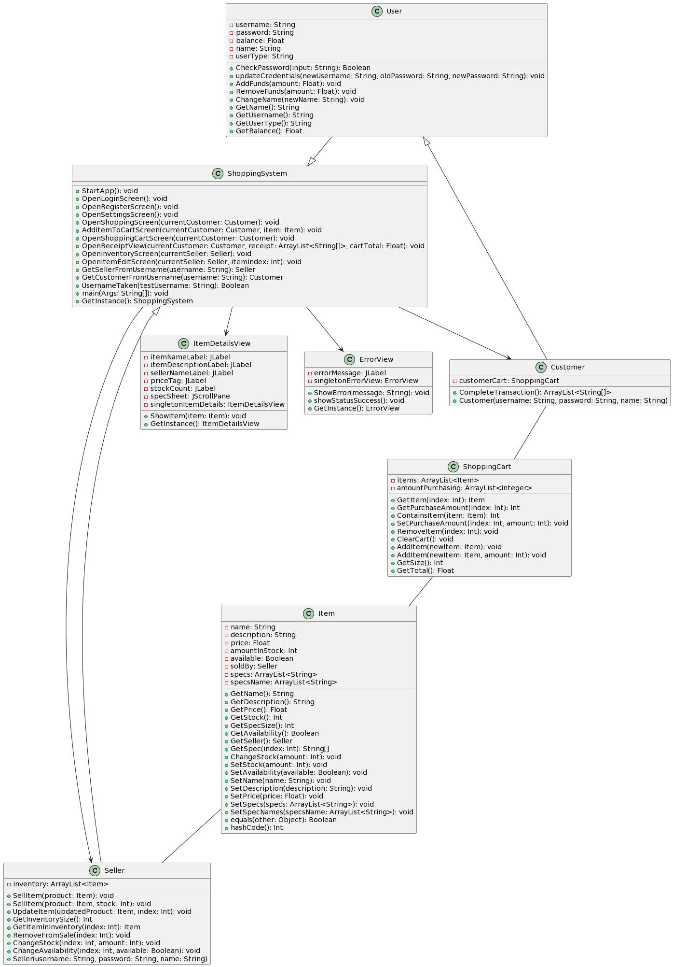

Sequence Diagrams

**User Logs In:**

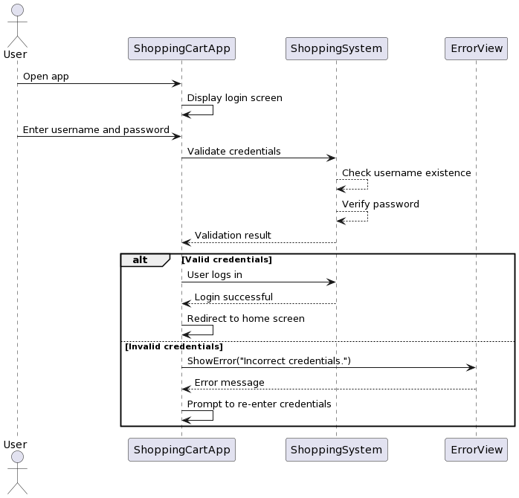

**User Changes/Updates their Login Credentials and Balance**

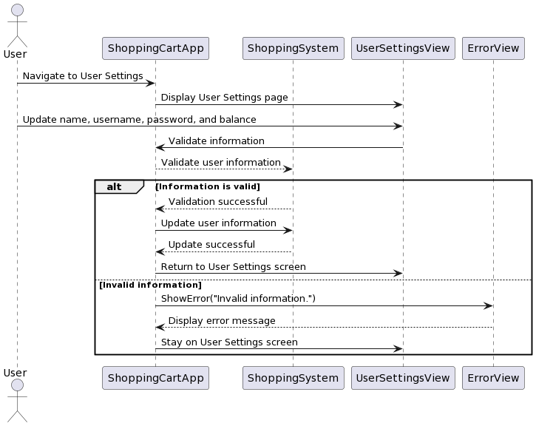

**Customer Reviews Product Details**

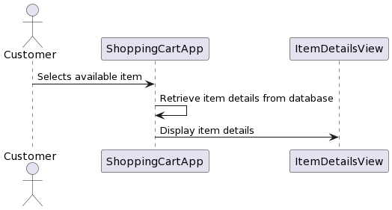

**Customer Reviews/Updates Shopping Cart**

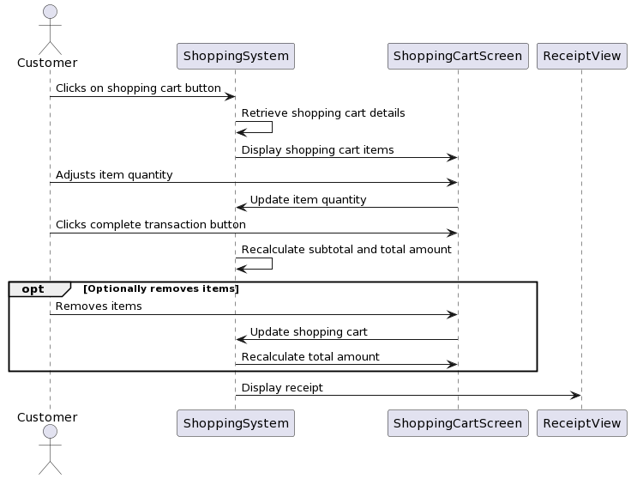

**Customer Checks Out**

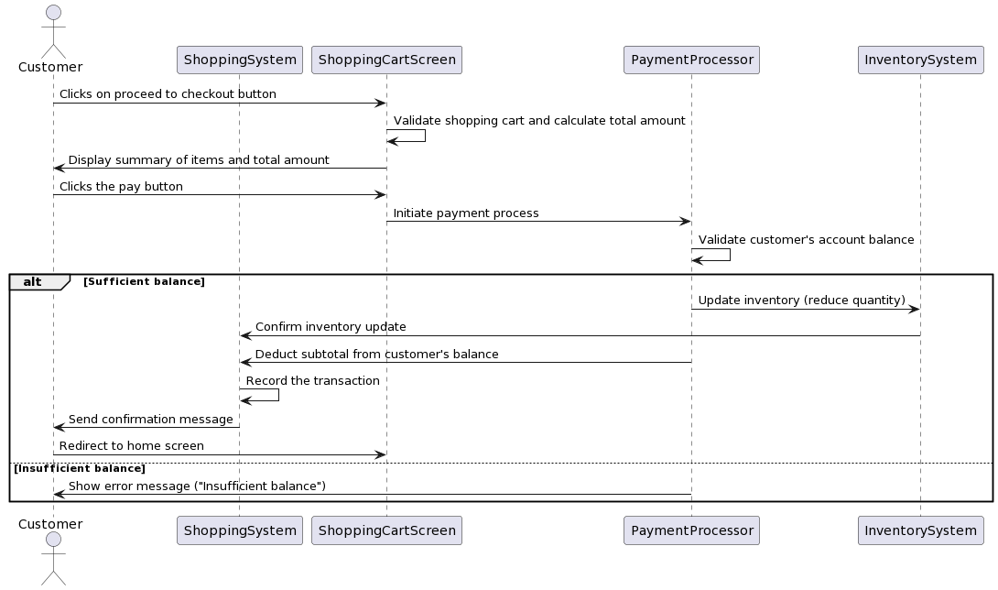

**Seller Reviews/Updates Inventory**

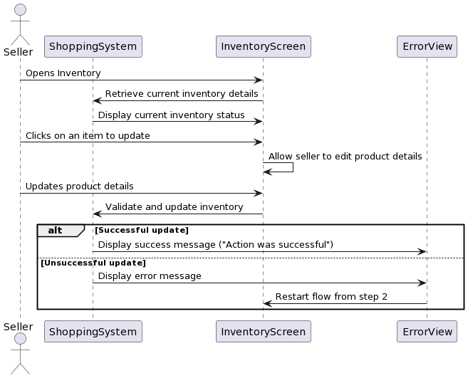

**Seller Adds New Product**

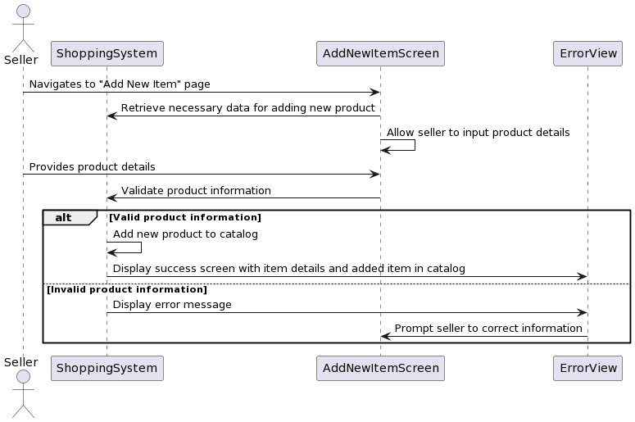

# State Diagram

